Week 4:
Step 1: I made a topology with host 1 and host 2 with router and switch.

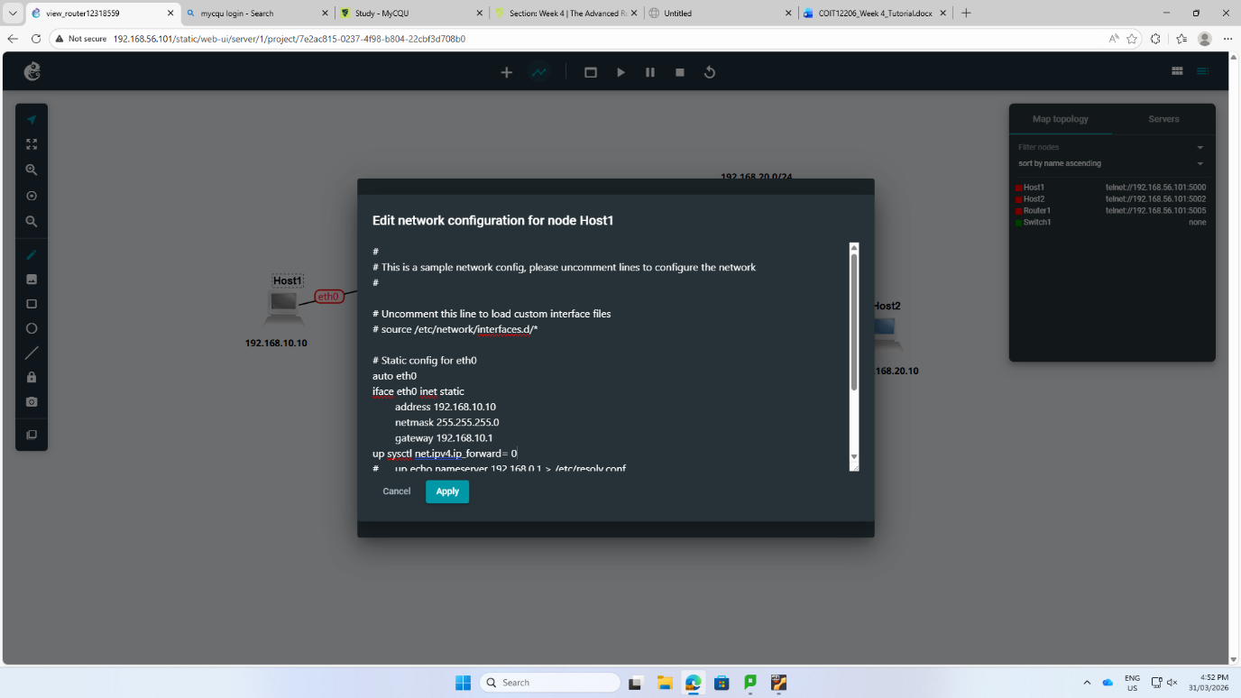
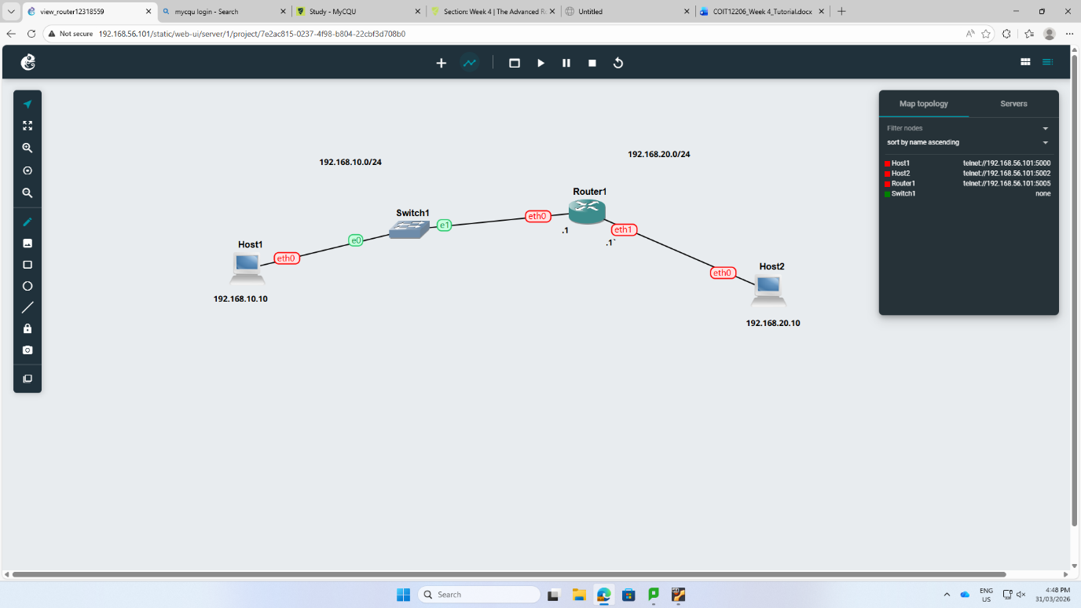
Step 2: I changed the IP address manually.

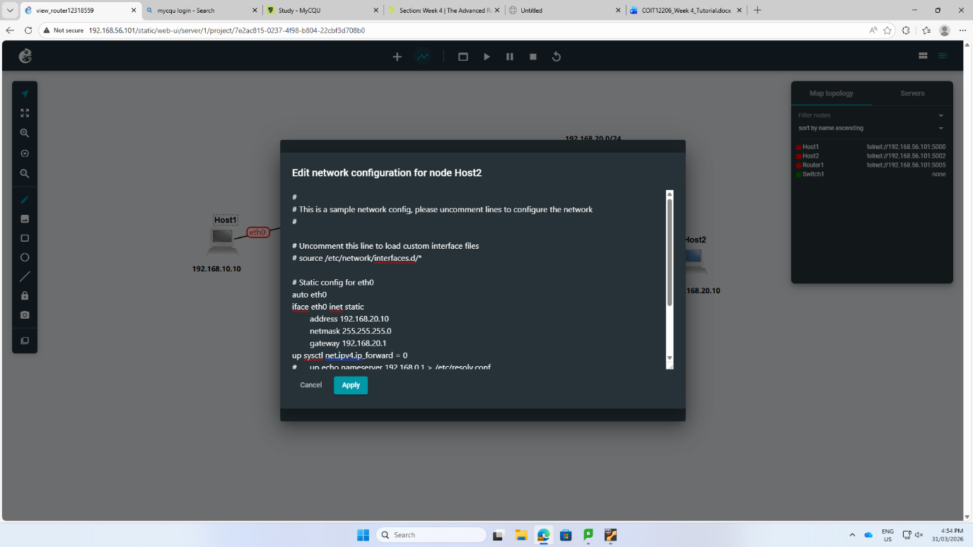

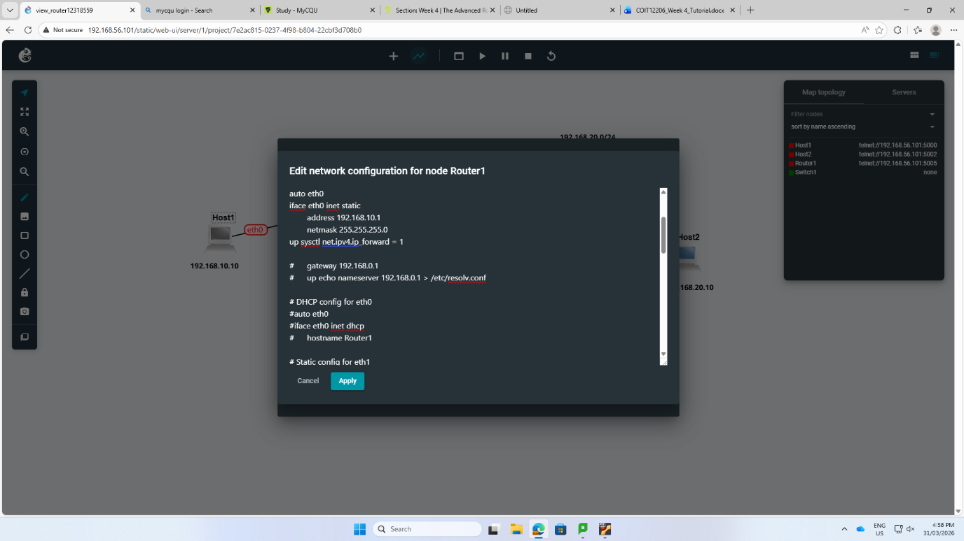
Step 3: I edit the configuration such as ip address, netmask of router 1.

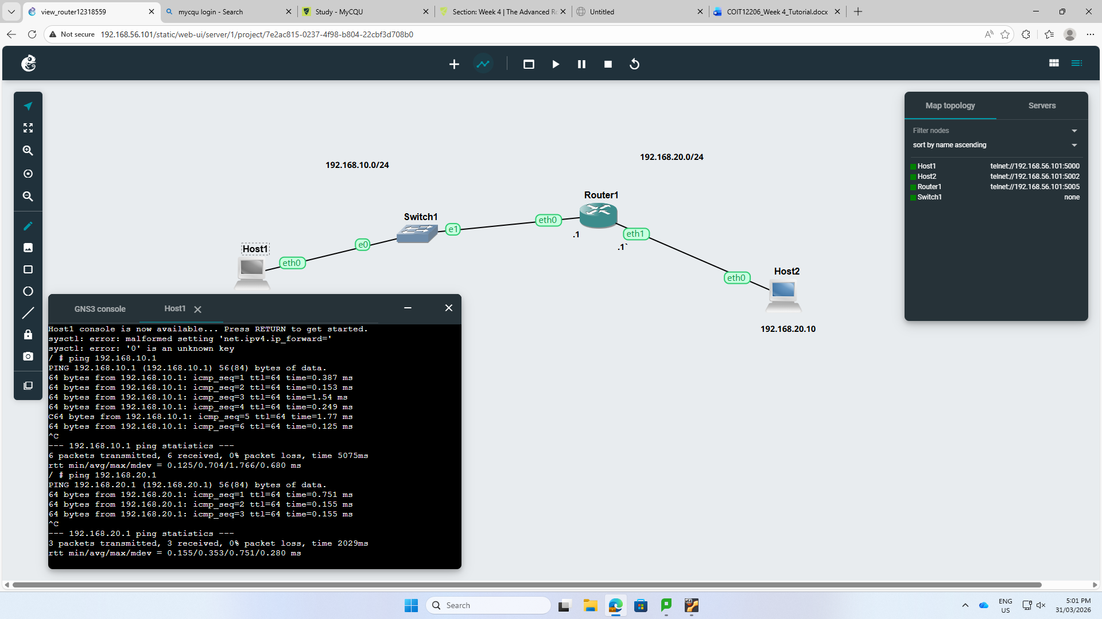
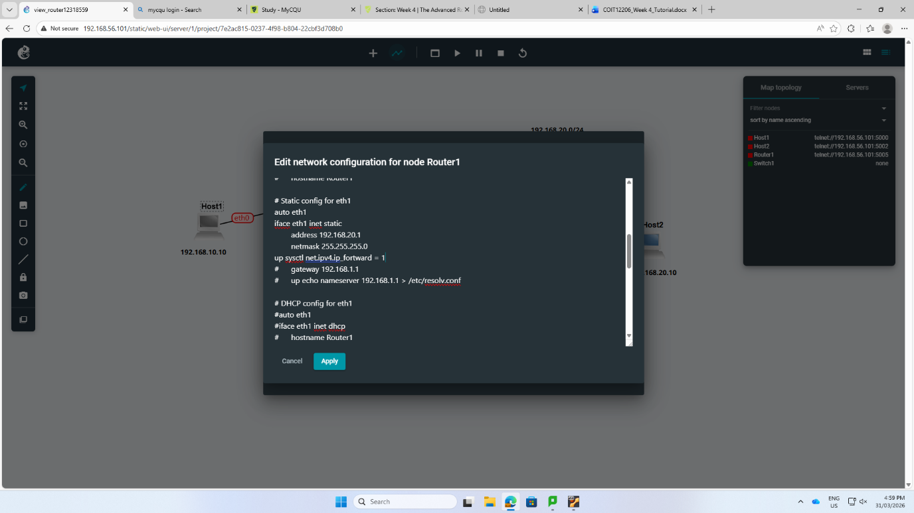
Step 4: I also set up router1 at eth0 at 192.168.10.1 and eth1 at 192.168.20.1.
Step 5: By mentioning the command sysctl net.ipv4.ip_forward=1 packet forwarding on the router was turned on to permit traffic to transfer through the variety subnets.

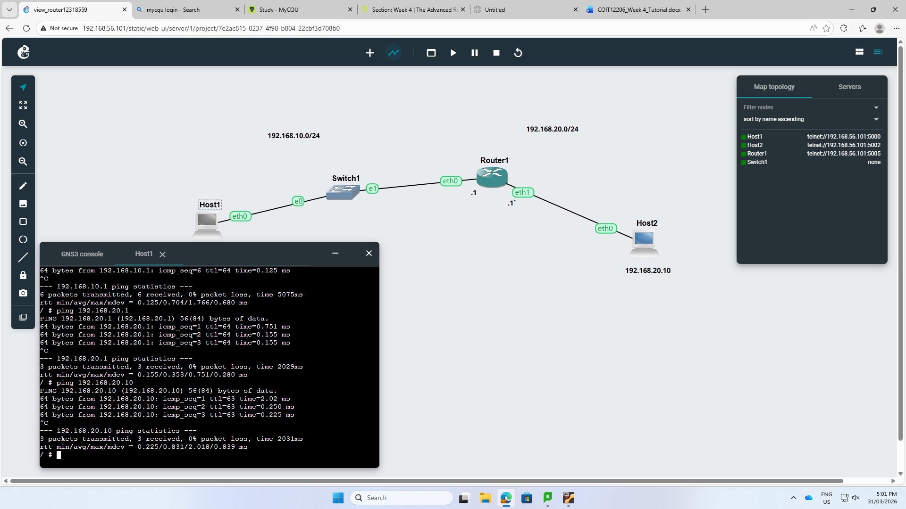
Step 6: The router used ip route show command to make sure active routes as well as to test connectivity from Host1 to Host 2 using ping command.

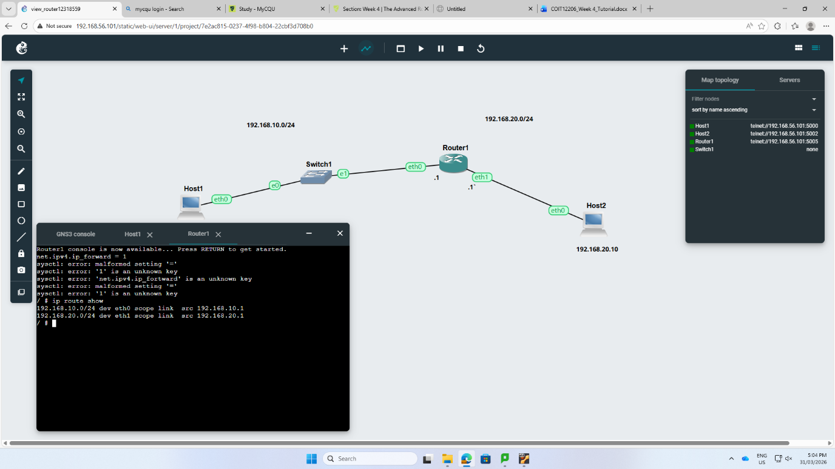
Second part:
Step 1: I also made a more advanced networking with 4 routers like FRR-1 within FRR-4 with two linux hosts. I downloaded it from the project and duplicate to see the topology.

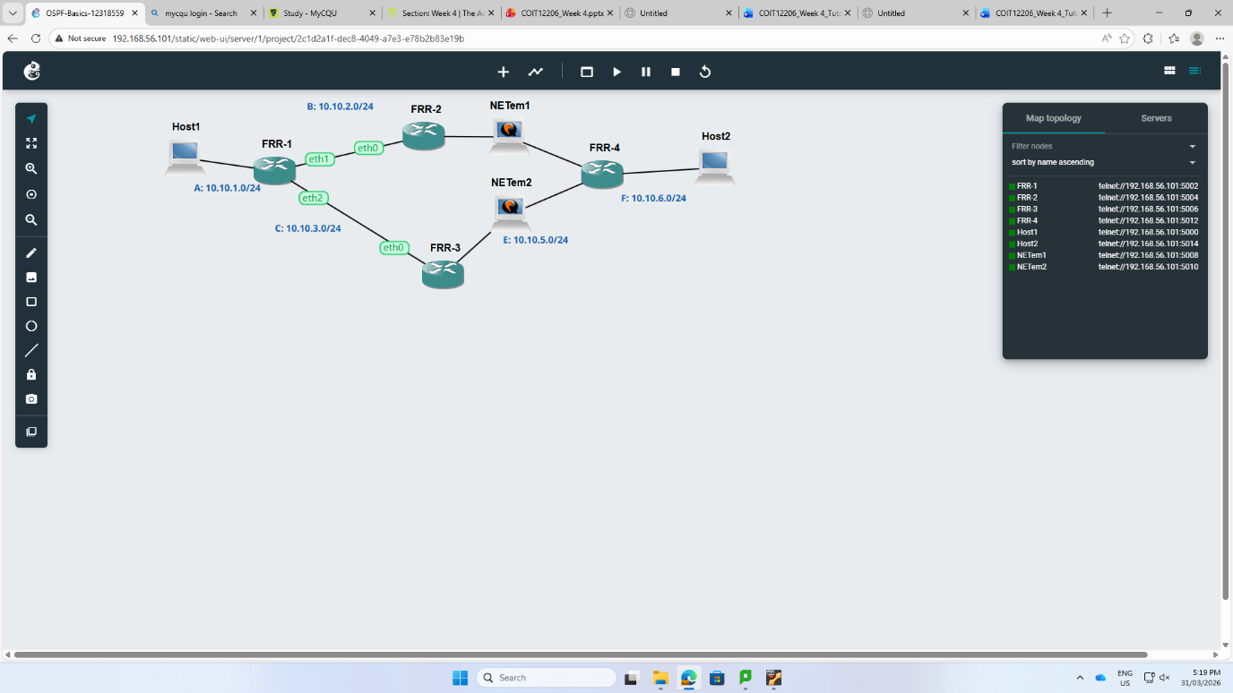
Step 2: The command show ip ospf neighbor was used to verify that routers are fully created approving ‘full’ adjacency states.
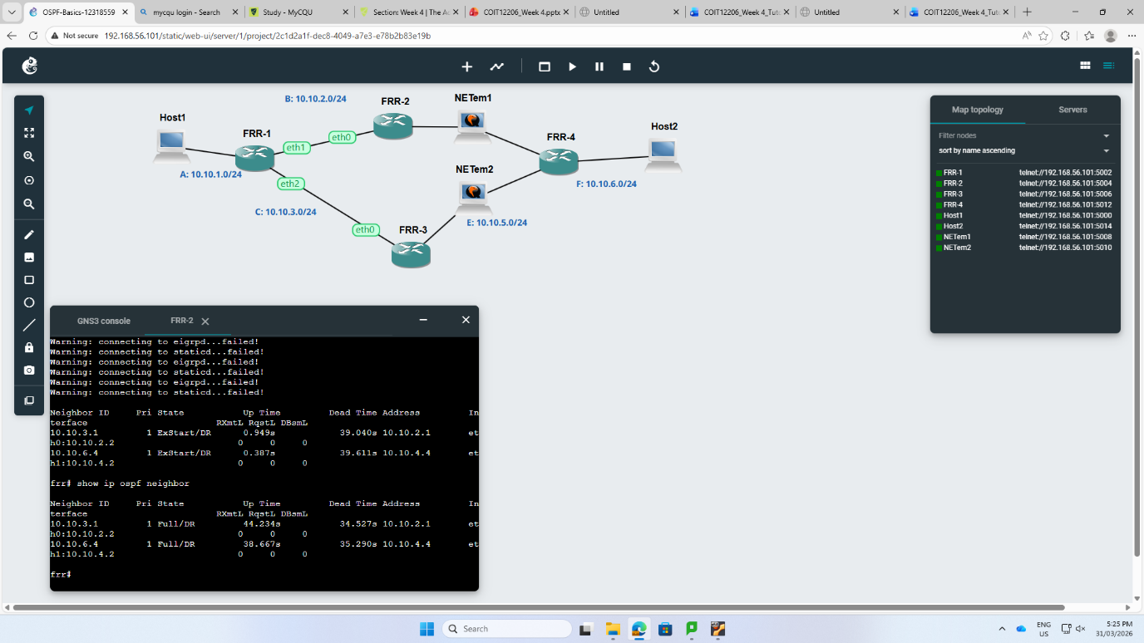

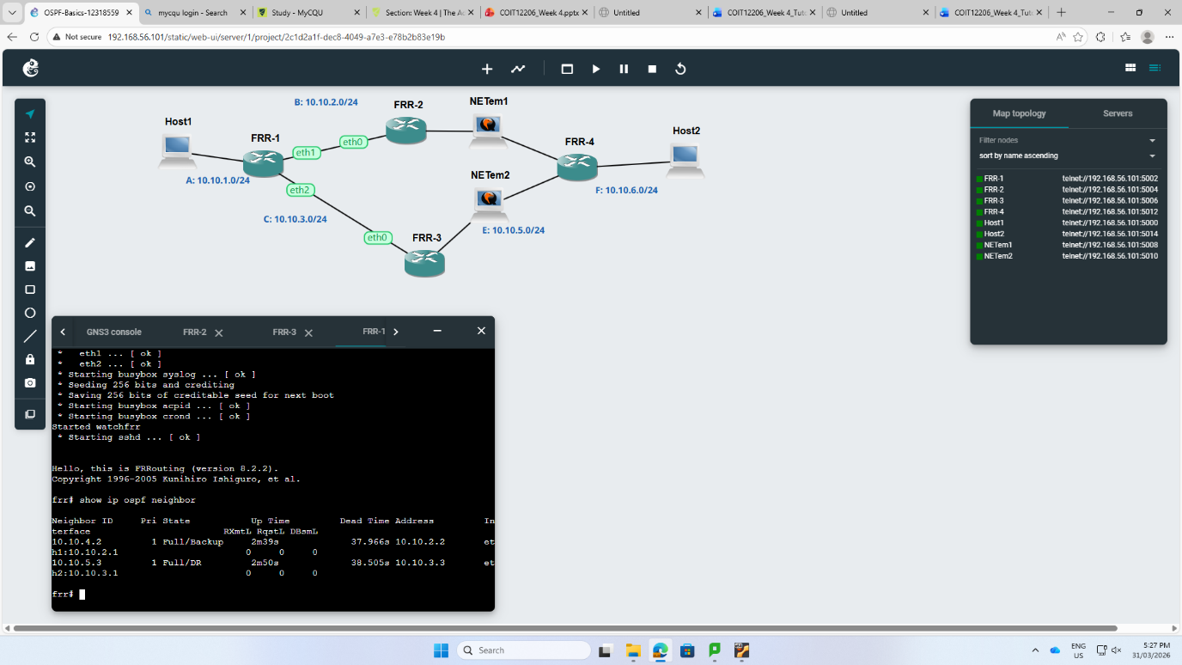
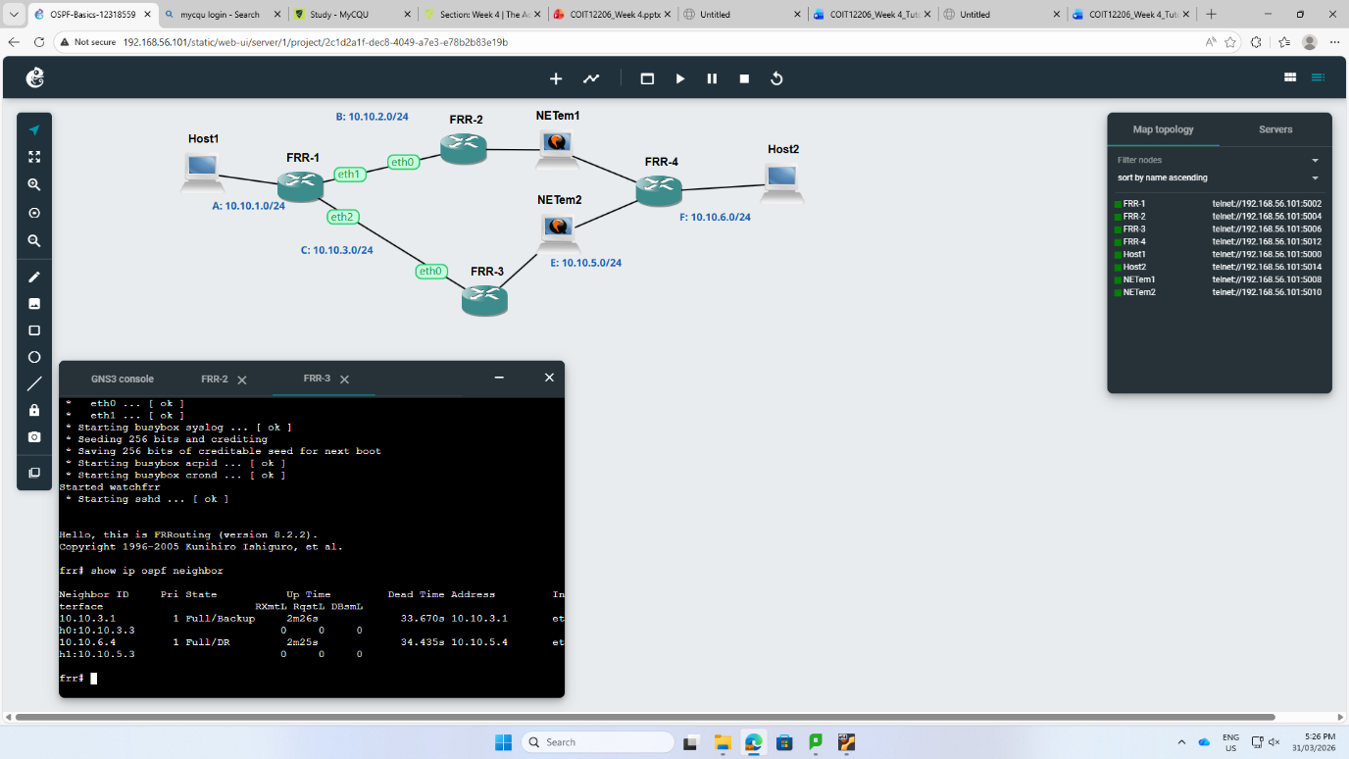

Step 3: The command ‘show ip route’ and ‘show ip ospf route’ is used to notice how OSPF directly calculated the best ways through the integrate topology.
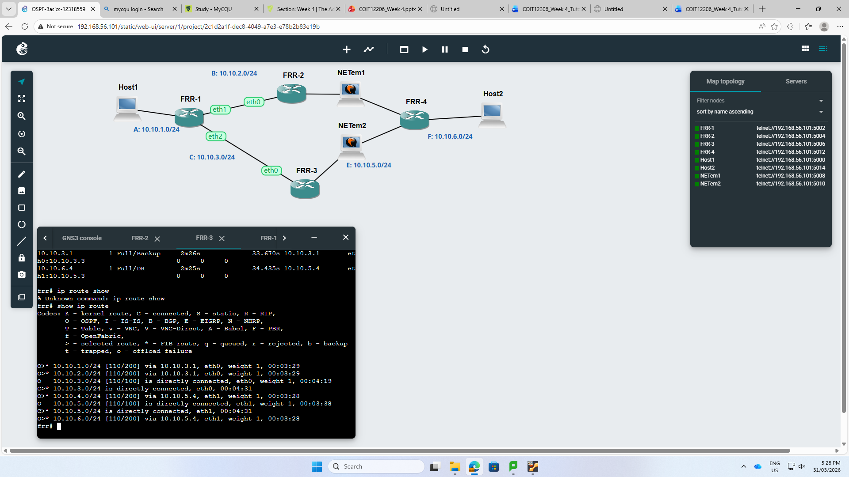

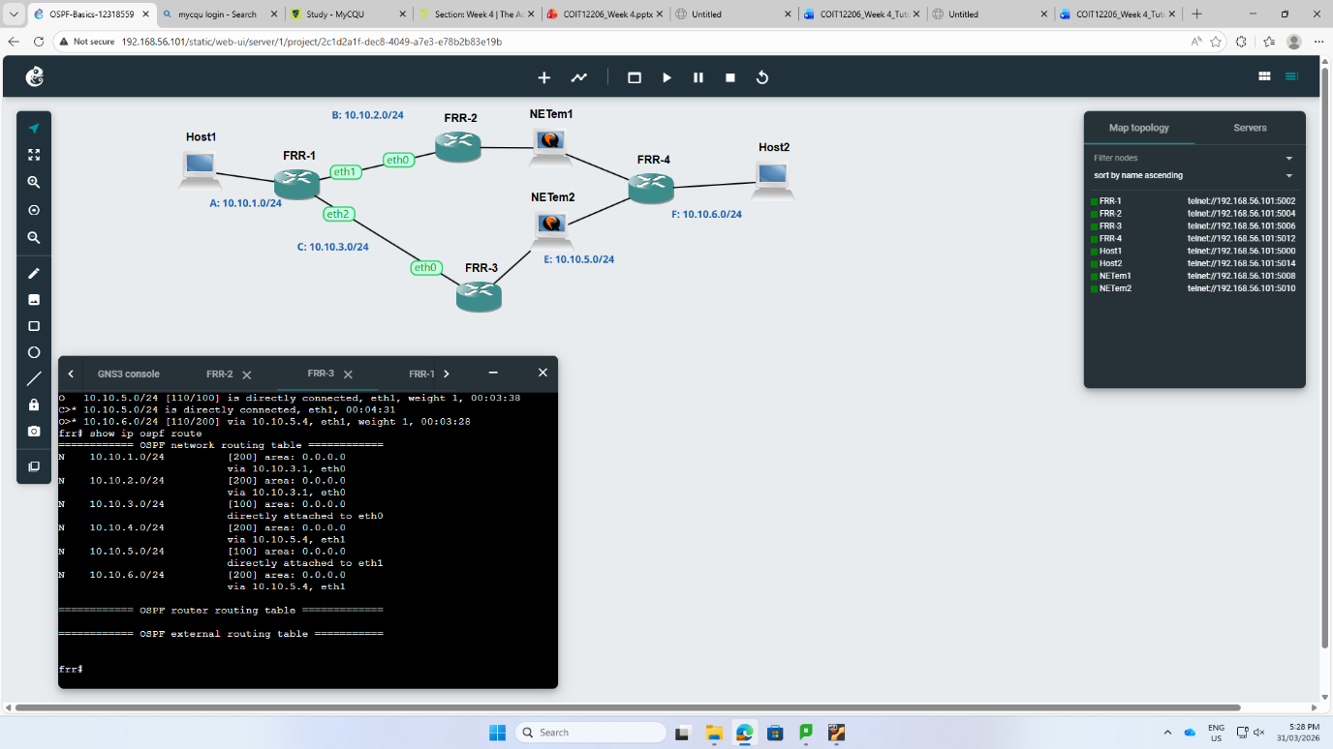

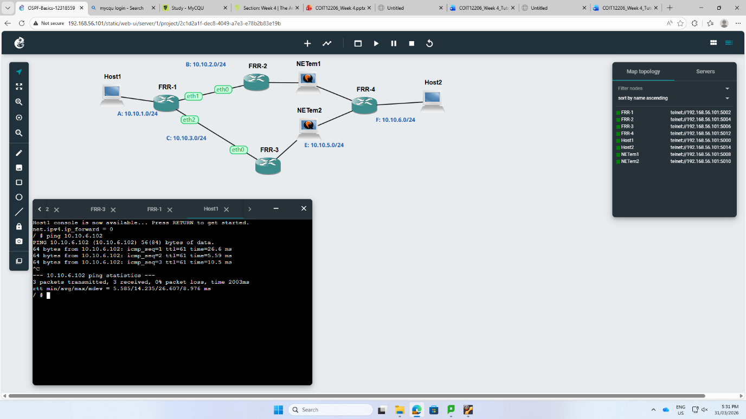

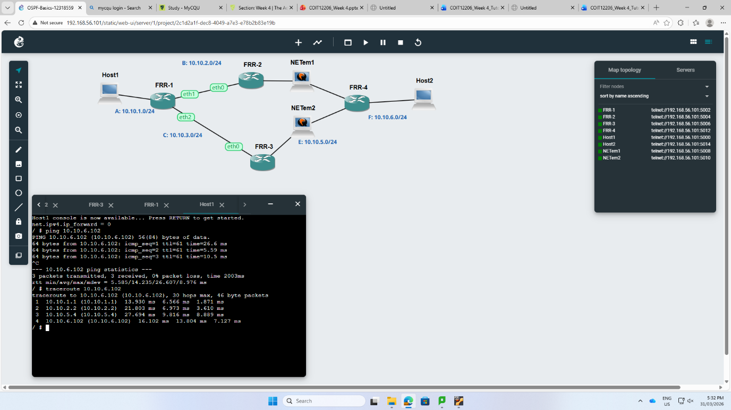
Reflection:
In week 4, I learned from setting up manual static routes to applying the OSPF dynamic routing protocol through a various-router topology. The main learning was knowing about that physical connections should have logical enablement, mainly starting IP forwarding via the interface to permit traffic movement across subnets. I confirmed successful neighbor adjacencies using a command like show ip ospf neighbor as well as traceroute. I also noticed the process of algorithm directly calculated effective data paths.

